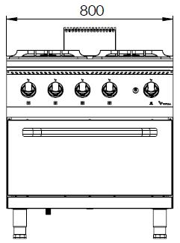

**GAZLI, 4 AÇIK ATEŞLİ KUZİNE FIRINLI**

**900'**

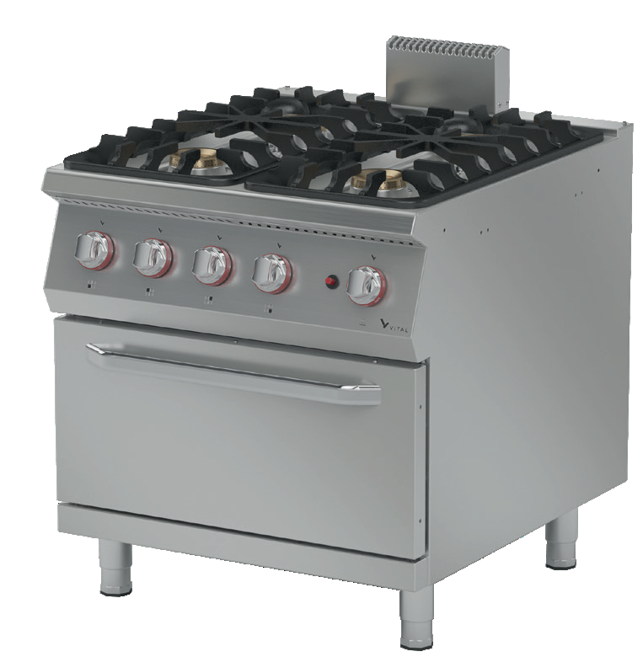

**PİŞİRME SERİSİ**

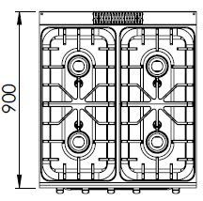

The stainless steel body makes the device durable and enduring.

Easy to clean through its rounded upper surface.

All burners are produced with special molds and pressed top.

The monoblock worktop increases the durability and ensures an easy cleaning.

The oven temperature is controlled with an adjustable thermostatic gas valve from 50 to 300°C.

The capacity of the oven is 2 x GN 2/1.

In order to put pots pans etc on the stove burners, cast iron cooker burners are available.

Safety gas valves provide safe operation.

A thermocouple for flame control is available.

High efficiency and low gas emission burners have been used.

Has a piezoelectric ignition system.

The thickness of the upper part is 1,5 mm AISI stainless steel.

The body sheets are 1 mm Scotch Brite stainless steel.

Can be operated with LPG or natural gas.

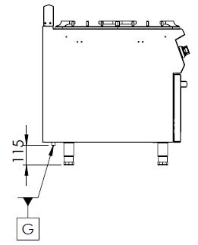

G=GAS INLET

|  |  |  |  |  |  |  |
| --- | --- | --- | --- | --- | --- | --- |
| **MODEL** | **DESCRIPTION** | **DIMENSIONS** | **TOTAL POWER** | **GAS CONSUMPTION** | | **WEIGHT** |
| GKF9020 | GAS RANGE | 800X900X850 | 52.4 kW | 5.546 max. / 2.911 min. | 4.133 max. /2.170 min. | 127 kg net |
| 820X960X1100 Package dimension | G20(m3/h) | G30 (kg/h) | 143 kg Gross weight |



|  |  |  |  |
| --- | --- | --- | --- |
| **HEADQUARTER** | | **FACTORY** | |
| Plevne Caddesi No.40/C | | Taşpınar Mevkii No.154 | |
| Gülveren-Mamak/ANKARA | | Çubuk/ANKARA | |
| Tel . | +90 312 363 94 93 | Tel . | +90 312 837 76 72 |
| Fax. | +90 312 363 94 92 | Fax. | +90 312 837 73 38 |
| [**www.mutasgroup.com**](http://www.mutasgroup.com/) **/** [**info@vitalmutfak.com**](mailto:info@vitalmutfak.com) | | | |