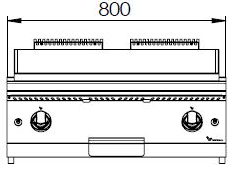

**GAS FRY TOP RIBBED**

**900'**

**COOKING SERIE**

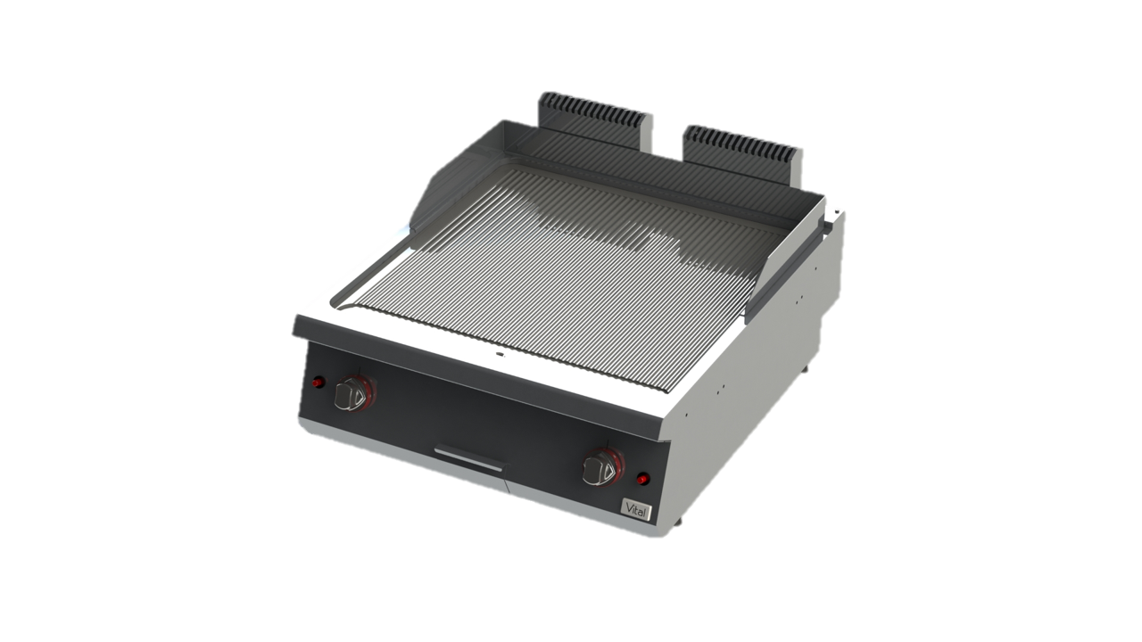

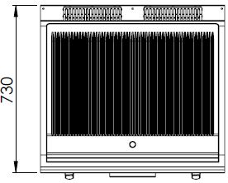

The stainless steel body makes the device durable and enduring.

Easy to clean through its rounded upper surface.

The device is produced with special molds and pressed top.

The monoblock worktop increases the durability and ensures an easy cleaning.

Has a removable stainless steel oil protector for the rear and side corners.

Thick steel surface. Optional chrome coating is available.

Holds a container with a capacity of 1,8 liter for waste oil.

Has a piezoelectric ignition system.

The thickness of the upper part is 1,5 mm AISI stainless steel.

The body sheets are 1 mm Scotch Brite stainless steel.

Can be used on countertop or on base cupboard.

Can be used with LPG or natural gas.

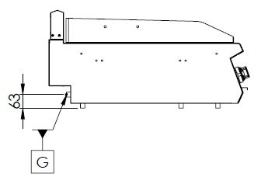

G=GAS CONNECTION

|  |  |  |  |  |  |  |
| --- | --- | --- | --- | --- | --- | --- |
| **MODEL** | **DESCRIPTION** | **DIMENSIOSN** | **TOTAL POWER** | **GAS CONSUMPTION** | | **WEIGHT** |
| GPI9020R | GAS FRY TOP | 800X900X280 | 19 kW | 2.011 max. / 1.056 min. | 1.498 max. /0.787 min. | 115 kg net |
| 820X960X490 Package dimension | G20(m3/h) | G30 (kg/h) | 125 kg  Gross weight |



|  |  |  |  |
| --- | --- | --- | --- |
| **HEADQUARTER** | | **FACTORY** | |
| Plevne Caddesi No.40/C | | Taşpınar Mevkii No.154 | |
| Gülveren-Mamak/ANKARA | | Çubuk/ANKARA | |
| Tel . | +90 312 363 94 93 | Tel . | +90 312 837 76 72 |
| Fax. | +90 312 363 94 92 | Fax. | +90 312 837 73 38 |
| [**www.mutasgroup.com**](http://www.mutasgroup.com/) **/** [**info@vitalmutfak.com**](mailto:info@vitalmutfak.com) | | | |