

**GAS INDIRECT BOILING PAN**

**900'**

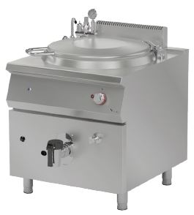

**COOKING SERIE**

Boiling pans provides different methods of cooking.

The stainless steel body makes the device durable and enduring.

Easy to clean through its rounded upper surface.

Easy opening and closing with its adjustable cover lifting mechanism.

Safety gas valves provide safe operation.

A thermocouple for flame control is available.

With the insulation material around the boiler, the energy saving is provided by minimizing the loss as much as possible.

The discharging valve provide an easy and secure draining.

The pressure safety valve prevents overheating for a secure usage.

The manometer indicator allows the observation of the internal wall pressure.

Possibilty to monitor the working status by the signal lamp located on the panel.

Composed with cold and hot water inlets.

The capacity of the pan is 150 liters.

The depth of the pan is 570 mm.

The thickness of the upper part is 1,5 mm AISI stainless steel.

The body sheets are 1 mm Scotch Brite stainless steel.

Can be operated with LPG or natural gas.

G=GAS INLET

WI=WATER INLET

|  |  |  |  |  |  |  |  |
| --- | --- | --- | --- | --- | --- | --- | --- |
| **MODEL** | **DESCRIPTION** | **DIMENSIONS** | **ELECTRIC INLET / CABLE CROSS SECTION** | **TOTAL POWER** | **GAS CONSUMPTION** | | **WEIGHT** |
| GKT90150 | GAS BOILING PAN | 800X900X850 | 220-230 VAC 50 HZ 1N PE  /  3X1,5 mm2 | 24 kW | 2.540 max. / 1.334 min. | 1.893 max. /0.994 min. | 160 kg net |
| 820X960X1200 Package dimension | G20(m3/h) | G30 (kg/h) | 180 kg Gross weight |



|  |  |  |  |
| --- | --- | --- | --- |
| **HEADQUARTER** | | **FACTORY** | |
| Plevne Caddesi No.40/C | | Taşpınar Mevkii No.154 | |
| Gülveren-Mamak/ANKARA | | Çubuk/ANKARA | |
| Tel . | +90 312 363 94 93 | Tel . | +90 312 837 76 72 |
| Fax. | +90 312 363 94 92 | Fax. | +90 312 837 73 38 |
| [**www.mutasgroup.com**](http://www.mutasgroup.com/) **/** [**info@vitalmutfak.com**](mailto:info@vitalmutfak.com) | | | |