

**ELECTRIC TILTING BRATT PAN**

**900'**

**COOKING SERIE**

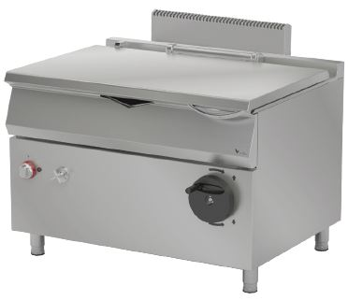

The stainless steel body makes the device durable and enduring.

Temperature adjustment up to 300°C.

The insulation material located in the pan base and in the front base minimizes heat loss and saves energy.

Manual lifting mechanism up to 90°.

Easy to clean through rounded corners.

The special designed resistances located under the cooking surface provide homogeneous temperature distribution inside the pan.

Composed with cold and hot water inlets.

The depth of the pan is 202 mm.

The capacity of the pan is 80 liters.

The thickness of the cover is 1 mm AISI stainless steel.

The thickness of the upper frame is 2 mm AISI stainless steel. The bottom sachet is 2 mm AISI stainless steel.

The coating sheets are 1 mm made of Scotch Brite stainless steel.

|  |  |  |  |  |  |
| --- | --- | --- | --- | --- | --- |
| **MODEL** | **DESCRIPTION** | **DIMENSION** | **TOTAL POWER** | **ELECTRIC VOLTAGE /**  **CABLE CROSS SECTION** | **WEIGHT** |
| EDT90120 | ELECTRIC TILTING BRATT PAN | 1200X900X850 | 18 kW | 380-400 VAC 3N 50 Hz  /  5X4 mm2 | 208 kg net |
| 1220X960X1050 Package dimension | 233 kg  Gross weight |



|  |  |  |  |
| --- | --- | --- | --- |
| **HEADQUARTER** | | **FACTORY** | |
| Plevne Caddesi No.40/C | | Taşpınar Mevkii No.154 | |
| Gülveren-Mamak/ANKARA | | Çubuk/ANKARA | |
| Tel . | +90 312 363 94 93 | Tel . | +90 312 837 76 72 |
| Fax. | +90 312 363 94 92 | Fax. | +90 312 837 73 38 |
| [**www.mutasgroup.com**](http://www.mutasgroup.com/) **/** [**info@vitalmutfak.com**](mailto:info@vitalmutfak.com) | | | |