

**ELECTRIC TILTING BRATT PAN**

**700'**

**COOKING SERIE**

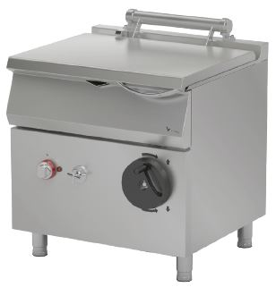

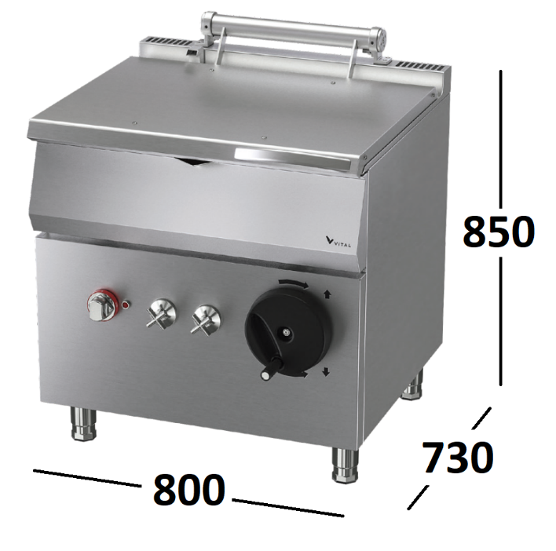

The stainless steel body makes the device durable and enduring.

Temperature adjustment up to 300°C.

8-level temperature adjustment for gas models with safety

component, thermocouple and pilot flame.

The insulation material located in the pan base and in the front base minimizes heat loss and saves energy.

Manuel tilting system, up to 90°.

Easy to clean through rounded corners.

Counterweighted hinged lid.

Cold water inlet.

The special designed resistances located under the cooking surface provide homogeneous temperature distribution inside the pan.

Incoloy 800 quality long life resistances resistant to high

temperature, lime corrosion and chemical use.

The pan thickness is 2mm, base of pan is 8 mm.

The depth of pan is 205 mm. The capacity of the pan is 50 liters.

The thickness of the lid is 1 mm AISI stainless steel.

The exterior is 1 mm made of Scotch Brite stainless steel.

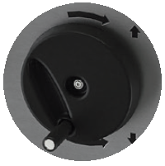

|  |  |  |  |  |  |
| --- | --- | --- | --- | --- | --- |
| **MODEL** | **DESCRIPTION** | **DIMENSIONS** | **TOTAL**  **POWER** | **ELECTRIC VOLTAGE /**  **CABLE CROSS SECTION** | **WEIGHT** |
| EDT7050 | ELECTRIC TILTING  BRATT PAN | 800X730X850 mm - Net | 8 kW | 380-400 VAC 3N 50 Hz / 5X4 mm2 | 110 kg - Net |
| 820X800X1100 mm - Brut | 125 kg - Brut |



|  |  |  |  |
| --- | --- | --- | --- |
| **HEADQUARTER** | | **FACTORY** | |
| Plevne Caddesi No.40/C | | Taşpınar Mevkii No.154 | |
| Gülveren-Mamak/ANKARA | | Çubuk/ANKARA | |
| Tel . | +90 312 363 94 93 | Tel . | +90 312 837 76 72 |
| Fax. | +90 312 363 94 92 | Fax. | +90 312 837 73 38 |
| [**www.mutasgroup.com**](http://www.mutasgroup.com/) **/** [**info@vitalmutfak.com**](mailto:info@vitalmutfak.com) | | | |