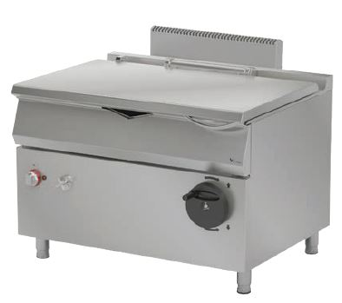

**AUTOMATIC TILTING ELECTRIC BRATT PAN**

**900' COOKING SERIE**

The stainless steel body makes the device durable and enduring.

The operating status of the device can be observed with the thermostat lamp on the panel.

Measures have been taken against overheating with the thermostat.

The insulation material located in the pan base and in the front base minimizes heat loss and saves energy.

All the corners in the pan have been rounded, which provides an easy cleaning.

The lifting and the lowering process of the device is simplified with the motor.

The adjustable spring lid mechanism ensures an easy usage.

In case of a power cut, pan lifting and lowering can be done with the manual lifting mechanism.

The upper and lower limit switches prevent the pan from over-raising and lowering. The pan stops the heating and the water filling process while it is being lifted, allowing a safe operation.

The special designed resitances located under the cooking surface provide homogeneous temperature distribution inside the pan.

Composed with cold and hot water inlets.

The depth of the pan is 202 mm.

The capacity of the pan is 120 liters.

Automatic lifting mecanism up to 90°.

Temperature adjustment up to 300 oC.

The thcinkess of the lower frame is 2 mm AISI stainless steel.

The coating sheets are 1 mm made of stainless steel.

The pan base is made of 8 mm stainless steel for the durability.

|  |  |  |  |  |  |  |
| --- | --- | --- | --- | --- | --- | --- |
| **MODEL** | **DESCRIPTION** | **DIMENSIONS** | **TOTAL POWER**  **/**  **MOTOR POWER** | **ELECTRIC VOLTAGE**  **/**  **CABLE CROSS SECTION** | **WATER INLET** | **WEIGHT** |
| EDT90120M | AUTOMATIC TILTING ELECTRIC BRATT PAN | 1200X900X850 | 18,1 kW  /  40 W | 380-400 VAC 3N 50 Hz / 5X4 mm2 | R 1/2 | 237 kg net |
| 1220X960X1050 Package dimension | 262 kg  Gross weight |



|  |  |  |  |
| --- | --- | --- | --- |
| **HEADQUARTER** | | **FACTORY** | |
| Plevne Caddesi No.40/C | | Taşpınar Mevkii No.154 | |
| Gülveren-Mamak/ANKARA | | Çubuk/ANKARA | |
| Tel . | +90 312 363 94 93 | Tel . | +90 312 837 76 72 |
| Fax. | +90 312 363 94 92 | Fax. | +90 312 837 73 38 |
| [**www.mutasgroup.com**](http://www.mutasgroup.com/) **/** [**info@vitalmutfak.com**](mailto:info@vitalmutfak.com) | | | |