

**AUTOMATIC TILTING ELECTRIC BRATT PAN**

**900' COOKING SERIE**

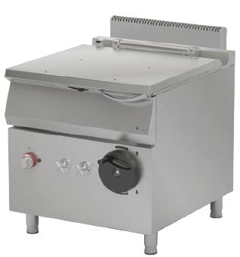

The stainless steel body makes the device durable and enduring.

The operating status of the device can be observed with the thermostat lamp on the panel.

Measures have been taken against overheating with the thermostat.

The insulation material located in the pan base and in the front base minimizes heat loss and saves energy.

All the corners in the pan have been rounded, which provides an easy cleaning.

The lifting and the lowering process of the device is simplified with the motor.

The adjustable spring lid mechanism ensures an easy usage.

The usage of the lid is facilitated with the adjustable lid mechanism.

In case of a power cut, pan lifting and lowering can be done with the manual lifting mechanism.

The upper and lower limit switches on the device prevents the pan from lifting or lowering morre than necessary.

When the pan is lifted, the heating and the water filling process stops in order to provide safe operation.

The special designed resistances located under the cooking surface provide homogeneous temperature distribution inside the pan.

Composed with cold and hot water inlets.

The depth of the pan is 202 mm.

The capacity of the pan is 80 liters.

Lifting mechanism up to 90°.

Adjustable temperature up to 300 oC.

The bottom sachet is 2 mm AISI stainless steel..

The coating sheets are 1 mm made of stainless steel.

The pan base is made of 8 mm stainless steel for the durability.

EI=ELECTRIC INLET

EQ=GROUNDING CONNECTION

W=WATER INLET

|  |  |  |  |  |  |  |
| --- | --- | --- | --- | --- | --- | --- |
| **MODEL** | **DESCRIPTION** | **DIMENSIONS** | **TOTAL POWER / MOTOR POWER** | **ELECTRIC VOLTAGE / CABLE CROSS SECTION** | **WATER INLET** | **WEIGHT** |
| EDT9080M | AUTOMATIC TILTING ELECTRIC BRATT PAN | 800X900X850 | 12,1 kW  /  40 W | 380-400 VAC 3N 50 Hz  /  5X4 mm2 | R 1/2 | 182 kg net |
| 820X960X1050 Package dimension | 202 kg  Gross weight |



|  |  |  |  |
| --- | --- | --- | --- |
| **HEADQUARTER** | | **FACTORY** | |
| Plevne Caddesi No.40/C | | Taşpınar Mevkii No.154 | |
| Gülveren-Mamak/ANKARA | | Çubuk/ANKARA | |
| Tel . | +90 312 363 94 93 | Tel . | +90 312 837 76 72 |
| Fax. | +90 312 363 94 92 | Fax. | +90 312 837 73 38 |
| [**www.mutasgroup.com**](http://www.mutasgroup.com/) **/** [**info@vitalmutfak.com**](mailto:info@vitalmutfak.com) | | | |