

**OTHER COOKING APPLIANCES**

**ELECTRIC INDIRECT BOILING PAN**

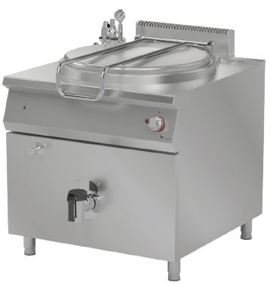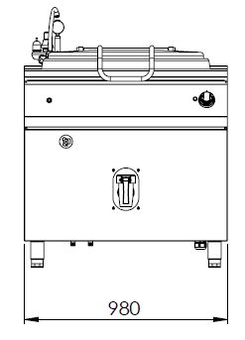

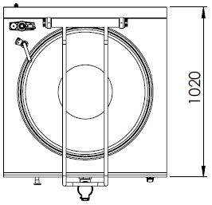

Boiling pans provides different methods of cooking.

The stainless steel body makes the device durable and enduring.

Easy to clean through its rounded upper surface.

The insulation material of the coating minimizes heat loss and saves energy.

Rounded corners of the interior enables an easy cleaning.

The special designed resistances located under the cooking surface provide homogeneous temperature distribution inside the pan.

The pressure safety valve prevents overheating for a secure usage.

The manometer indicator allows the observation of the internal wall pressure.

The discharging valve provide an easy and secure draining.

Adjustable temperature up to 200°C.

Composed with cold and hot water inlets.

The dept of the pan is 650 mm.

The capacity of the pan is 250 liters.

The thickness of the upper part is 1,5 mm AISI stainless steel.

The body sheets are 1 mm Scotch Brite stainless steel.

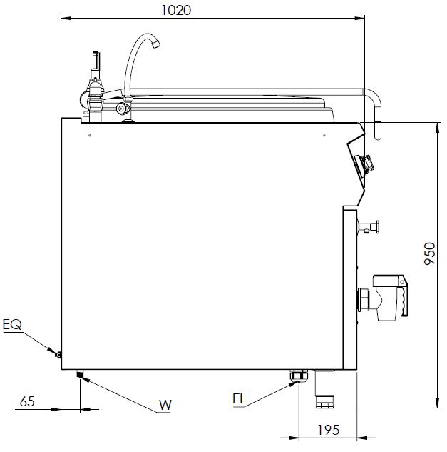

EI=ELECTRIC INLET

EQ=GROUNDING CONNECTION

W=WATER INLET

|  |  |  |  |  |  |
| --- | --- | --- | --- | --- | --- |
| **MODEL** | **DESCRIPTION** | **DIMENSIONS** | **TOTAL POWER** | **ELECTRIC VOLTAGE /**  **CABLE CROSS SECTION** | **WEIGHT** |
| EKT90250 | ELECTRIC BOILING PAN | 980X1020X950 | 36 kW | 380-400 VAC 3N 50 Hz  /  5X10 mm2 | 215 kg net |
| 1000X1080X1300  Package dimension | 240 kg  Gross weight |



|  |  |  |  |
| --- | --- | --- | --- |
| **HEADQUARTER** | | **FACTORY** | |
| Plevne Caddesi No.40/C | | Taşpınar Mevkii No.154 | |
| Gülveren-Mamak/ANKARA | | Çubuk/ANKARA | |
| Tel . | +90 312 363 94 93 | Tel . | +90 312 837 76 72 |
| Fax. | +90 312 363 94 92 | Fax. | +90 312 837 73 38 |
| [**www.mutasgroup.com**](http://www.mutasgroup.com/) **/** [**info@vitalmutfak.com**](mailto:info@vitalmutfak.com) | | | |