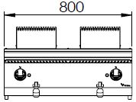

**FULL MODULE ELECTRIC BAIN-MARIE**

**900'**

**COOKING SERIE**

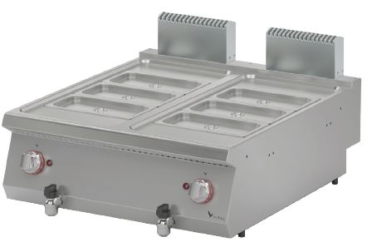

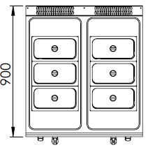

The stainless steel body makes the device durable and enduring.

Easy to clean through its rounded upper surface.

The device is produced with special molds and pressed top.

The monoblock worktop increases the durability and ensures an easy cleaning.

It can be controlled with a 30-90 oC adjustable thermostat.

Fast and safe way to drain the water throught its drain valve.

Suitable structure of tank for gastronorm containers.

The thickness of the upper panel is 1,5 mm and made of AISI 304 stainless steel.

The body sheets are 1 mm and made of Scotch Brite stainless steel.

Can be used on worktops or cupboards.

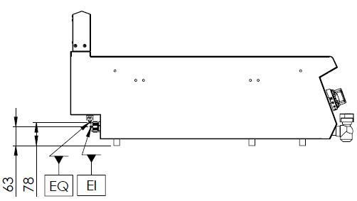

EI=ELECTRIC INLET

EQ=GROUNDING CONNECTION

|  |  |  |  |  |  |
| --- | --- | --- | --- | --- | --- |
| **MODEL** | **DESCRIPTION** | **DIMENSIONS** | **TOTAL POWER** | **ELECTRIC VOLTAGE /**  **CABLE CROSS SECTION** | **WEIGHT** |
| ESB9020 | ELECTRIC BAIN MARIE | 800X900X280 | 3 kW | 230 VAC 1N 50Hz  /  3X1.5 mm2 | 46 kg net |
| 820X960X450 Package dimensions | 56 kg  Gross weight |



|  |  |  |  |
| --- | --- | --- | --- |
| **HEADQUARTER** | | **FACTORY** | |
| Plevne Caddesi No.40/C | | Taşpınar Mevkii No.154 | |
| Gülveren-Mamak/ANKARA | | Çubuk/ANKARA | |
| Tel . | +90 312 363 94 93 | Tel . | +90 312 837 76 72 |
| Fax. | +90 312 363 94 92 | Fax. | +90 312 837 73 38 |
| [**www.mutasgroup.com**](http://www.mutasgroup.com/) **/** [**info@vitalmutfak.com**](mailto:info@vitalmutfak.com) | | | |