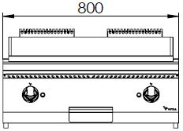
ELECTRIC FRY TOP

700'
COOKING SERIE
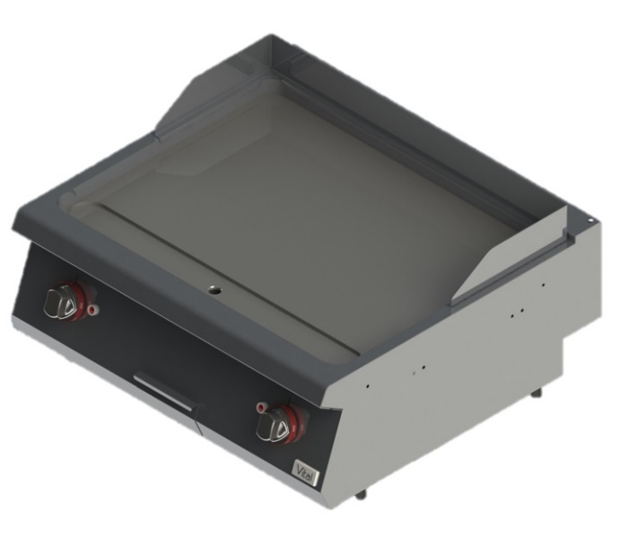

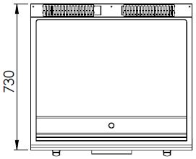

The stainless steel body makes the device durable and enduring.
Easy to clean through its rounded upper surface.
The device is produced with special molds and pressed top.
The monoblock worktop increases the durability and ensures an easy cleaning.
With removable stainless steel oil protector for the rear and side corners.
The special designed resistances located under the cooking surface provide homogeneous temperature distribution on the cooking surface. The heaters increase fastly the surface’s temperature to the required value.
15 mm thick steel surface. Optional chrome coating is available.
The temperature of the cooking surface can be adjusted with the thermostat from 50°C to 300°C.
Holds a capacity of 1,8 liter for waste oil.
The thickness of the upper part is 1,5 mm AISI stainless steel.
The body sheets are 1 mm Scotch Brite stainless steel.
Can be used on countertop or on base cupboard.

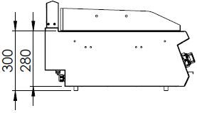

EI=ELECTRIC INLET
EQ=GROUNDING CONNECTION

MODEL | DESCRIPTION | DIMENSIONS | TOTAL POWER | ELECTRIC VOLTAGE / CABLE CROSS SECTION | WEIGHT
EPI7020S | ELECTRIC FRY TOP | 800X730X280 | 9 kW | 380-400 VAC 3N 50 Hz  /  5X4 mm² | 93 kg net
 |  | 820X800X530  Package dimension |  |  | 102 kg  Gross weight

HEADQUARTER |  | FACTORY
Plevne Caddesi No.40/C |  | Taşpınar Mevkii No.154
Gülveren-Mamak/ANKARA |  | Çubuk/ANKARA
Tel . | +90 312 363 94 93 | Tel . | +90 312 837 76 72
Fax. | +90 312 363 94 92 | Fax. | +90 312 837 73 38
www.mutasgroup.com / info@vitalmutfak.com

